**MIDDLE EAST TECHNICAL UNIVERSITY**

**DEPARTMENT OF ELECTRICAL & ELECTRONICS ENGINEERING**





**TROY TECH**

**CONCEPTUAL DESIGN REPORT**

**Section:** 7

**Studio Coordinator:** Mustafa Mert ANKARALI

**Partners:**

Hasan ÖZKARA - 2031888

Kağan ÖZASLAN - 2031854

Caner POTUR - 2031250

Mustafa Ercan OKATAN - 2031193

Mert KAYIŞ - 2030997

**TABLE OF CONTENTS**

1. Executive Summary ........................................................................................................... 3

2. Introduction ........................................................................................................................ 4

3. Solutions ............................................................................................................................ 4

3.1. Overall description of the system ........................................................................ 4

3.2. System level flowchart ........................................................................................ 5

3.3. Description of individual sub-systems ................................................................. 6

3.4. Restatement of system level requirements.......................................................... 7

3.5. Solution for each subsystem................................................................................ 8

3.5.1 Analog Video transfer sub-system……….............................................. 8

3.5.2 Command Transmission sub-system…................................................. 9

3.5.3 Motor-drive sub-system………...............................................................13

3.5.3.1 Motors……………………………………………………………...13

3.5.3.2 Encoder…………………………………………………………….13

3.5.3.3 Differential Drive…………………………………………………..14

3.5.3.4 DC Motor Drive with Arduino ……………………………………15

3.5.4 Shooting sub-system…………………..…...............................................19

3.5.4.1 Spring Mechanism………………………………………………..19

3.5.4.2 Solenoids………………………………………………………..... 21

3.5.5 Power Supply Subsystem………………………………………………….. 21

3.6 Subsystem level risk assessment, and alternative solutions (Plan-B).................. 22

3.6.1 Video transmission subsystem: range…………………………...……….. 22

3.6.2 Motor Drive System: Defense………………………………………..……..23

3.6.2.1 Using Movable Camera…………………………………………..23

3.6.2.2 Using Omni Wheels……………………………………………… 23

3.7 Error sources ....................................................................................................... 25

3.8 Test procedures ................................................................................................... 25

3.9 Technical drawing of the expected design……….……………………...…….…… 26

4. Plans ................................................................................................................................ 29

4.1. Planned work and responsibilities among the project team members ............... 29

4.2. Gantt Chart……………………………………………………………………………. 30

4.3. Foreseeable Difficulties ..................................................................................... 30

4.4. Test plans.......................................................................................................... 31

4.5. Cost Analysis ..................................................................................................... 31

4.6. Deliverables ........................................................................................................32

5. Conclusion …………..……………………………………………………………………………32

6. Disclaimer ………………………………………………………………………………………. 33

7. References………………………………………………………………………………………. 34

APPENDICES……………………………………………………………………………………… 35

**1.Executive Summary**

Nowadays, robotic solutions for new technological products include both tele-operation and autonomous actions. As Troy Tech, we are working on the tele-operation side and developing new solutions for wireless operations. We aim both financial efficiency and reliable operation in our project. Integration of different systems sometimes become problematic, but we are trying to predict possible difficulties and gather all the parts together in a compatible way.

Our ongoing project requires a robot playing football in a hexagonal playfield. It is supposed to be controlled from at least 30-meters for indoor usage. Tele-operation will be done by just looking at a screen showing the live broadcast. The video recorded by the camera that is located on the robot will instantly transferred to the controlling side.

Our teleoperated robot, Helen-V consists of four subsystems which are video transmission, command transmission, motor control and shooting mechanism. We gave priority to solve the problem of transferring the live video data with minimum latency from the robot to the controlling side. After doing some research on this problem, we ordered items for this part and did some tests and quality controls. At the beginning, our camera unit was integrated with the video-transmitting antenna. Then we replaced it by a transmitter with higher power and externally connected camera. This replacement enhanced the distance that video signal reaches both indoor and outdoor areas. The second sub-system is the command transfer where we used digital data transfer from the controlling side to the robot. This sub-system includes two Arduino unos connected to NRF24L01 transceivers. We replaced their antennas with larger ones with higher gain in order to increase the communication range. The other part consists of two DC motors and one motor driver. This motor unit takes controlling data from the Arduino uno connected to the receiver NRF24L01. The last sub-system includes the mechanism to shoot the ball into the opponent’s goal. This part is also supplied by the digital signal coming from the command transfer system.

Although this project has many challenging aspects like the wireless data transfer to 30-meters, our group members-built consensus on this project involves much fun and the final product will satisfy our engineering enthusiasm.

**2.INTRODUCTION**

In this conceptual design report, we will explain the solutions that we come up with for the problems we face, or we predict that we will face in the remaining parts of our project in the remaining time period. For each problem, statements for both our current solution and alternative plans will be included. We try to build back-up plans for each problem in case of any trouble.

Problem statement:

           Our overall design will solve the problems listed below:

→ To score into the opponent’s goal by hitting the ball with an appropriate shooting mechanism

→ To control the robot by tele-operation method, the instantaneous video data is supposed to be transferred into the screen that controller looks while operating the robot remotely.

→ To transmit the signals that control both motors and shooting sub-system

→ To drive all the motors with correct speed in order to achieve smooth and accurate motion of the robot on the playfield

→ To shoot the ball with enough kinetic energy

Design Requirements:

Provide a system controllable from at least 30-meter for indoor application. Our robot is not allowed to pass beyond the centerline. The latency in the wireless communication should be minimized because the controller will not observe the playfield with naked eye or the playfield will not be in line of sight. The total cost of the project is limited by 200 dollars.

**3.SOLUTIONS**

**3.1. Overall Description of The System**

Our project consists of three main subsystems; analog video transfer, command transfer, motor drive and shooting mechanism. The analog transfer subsystem is separate while other parts are jointed.

We used a video camera for monitoring the game field and we preferred TS5828 transmitter in order to transmit the signal coming from the video camera. Then, we received the signal by the Rotg02 receiver module and transferred the video to a screen (android smartphone or pc) for monitoring the video of the game field. The whole process forms our analog video transfer subsystem.

Moreover, we have a command transfer subsystem which consist of a controller, an arduino microcontroller and two NRF24 transceiver (one for receiver, another one for transmitter) successively. Also, we have one more arduino microcontroller connected to the receiver NRF24. Finally, we have a L298N dual motor drive and motors connected successively, which forms motor drive subsystem, and we have shooting mechanism connected to the arduino. The overall block diagram can be seen in Figure 1.



*Figure 1. Overall block diagram of the project.*

**3.2. System Level Flowchart**



*Figure 2. Flowchart of video transmission system*



*Figure 3. Flowchart of command transmission and motor drive systems*

**3.3. Description of Subsystems**

**i) Analog Video Transfer Subsystem**

We were asked for providing wireless video transfer for at least 30m distance indoor. We used a fpv video camera and transmitter-receiver pair in order to transfer the video which is recorded by the video camera. The frequency of the transmitted signal is 5.8GHz (we are able to select the channel between 5.6GHz and 5.9GHz.) while its power is 600mW.

**ii) Command Transfer Subsystem**

Like in video transfer, we are asked for transfering command information for at least 30m distance indoor. We use a ps1 joystick in order to give appropriate command information. Then, we used NRF24L01 transceiver modules in order to transmit the information coming from the joystick. In order to receive the incident signal we used one more NRF24 transceiver as receiver. The operating frequency of the NRF24 transceiver is 2.4 GHz.

**iii) Motor Drive Subsystem**

We used 2 DC motors and 2 ball bearing caster wheels for the movements of our robot on the floor. This subsystem is responsible for all the rotating and linear movements to approach the ball before shooting or the defense of the goal. In order to provide each motor with enough amount of current, we made use of motor-driving  integrated circuit L298N which includes power transistors inside.

**iv) Shooting Subsystem**

The shooting mechanism is also an essential part of our project. We proposed three different shooting mechanisms for our robot. These consist of spring, pneumatic and solenoid based solutions to shoot the ball towards the goal. After our researches, we preferred these systems due to specific reasons. Firstly, spring system works very powerful. Secondly, pneumatic system is very cheap and easy to design. The last one, solenoid system uses magnetic power so it needs only transformer, capacitor and resistor.

**3.4. Restatement of system level requirements**

**i) Analog Video Transfer Subsystem**

This subsystem requires an instantaneous vision from the camera on-board the robot. There are different types of solutions here, but we have chosen to send the FPV camera output just as it is. We did not include any image processing technique here or any other process on the image because they result in a considerable latency between the transmitter and receiver units.

**ii) Command Transfer Subsystem**

Command transfer subsystem is supposed to have all the functions that robot movements require. These movements include DC motor motion and action of the shooting system. Since the control unit has both the monitoring of the instantaneous video and transmitter part of the command control, this subsystem needs to be able to reach at least 30-meters range for indoor usage.

**iii) Motor Drive Subsystem**

This subsystem is required to have enough power and accuracy to move the robot as desired.

**iv) Shooting Subsystem**

Shooting system is required to have a stable mechanism so that every shoot has enough power to hit the ball in the desired direction to score.

**3.5. Solution for each subsystem**

**3.5.1 Video transfer Subsystem**

We transfer the video as analog. It is the simplest and fastest way. Latency in analog transmission is less than other video transmission techniques (i.e. using image process technique ,using 3g internet) . We chose 5.8 GHz for video transmission due to its high transfer rate. It provides a better video stream than 2.4Ghz, 900 MHz and 433 MHz. This subsystem consists of transmitter and receiver systems:

**i) Transmitter:**

We used a 600mw 5.8 GHz transmitter to transmit the video coming from a mini camera (Eachine TS5828S 40CH 5.8G 600MW) as shown in Fig. 4. It provides a high maximum range using its stock antenna. However, it can be upgraded by using different antennas or using power amplifier.

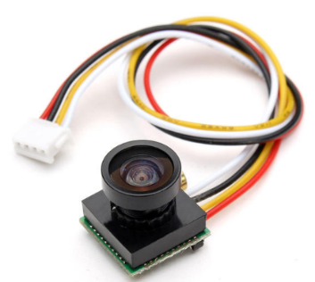

*Figure 4. TS5828S and 600TVL mini camera*

**ii) Receiver:**

We used ROTG02 as a 5.8Ghz FPV receiver. Advantages:

* Good signal reception
* Dual antenna system
* 150 reception channels (5645~5945 frequency range)
* Low latency (around 100 ms)
* It can be connected to a smartphone (OTG)
* Antennas can be improved



*Figure 5. Eachine ROTG02*

**3.5.2 Command Transfer Subsystem**

**i) Command Transmitter**

We built a command transmitter unit using PS1 joystick and NRF24L01 2.4Ghz transmitter as shown in Fig. 6. and Fig. 7.



*Figure 6. Command Transmitter unit*



*Figure 7. Command Transmitter unit with antenna*

We chose NRF24L01 because of some reasons.

* It is very cheap.
* Compatible with high gain antennas and 2.4ghz antennas are also very cheap.
* Transmitter output power is 20dBm.
* It has easy to use libraries and adjustable settings by many MCU and compatible with them.
* It has safety communication. It can use upon 5-byte configurable network address to communicate just in a specific network branch.
* It is easy to power-up. There is no need for additional power supply, we connected NRF modules directly to the Arduino to be energized.



*Figure 8. NRF24L01*

In our system, we use 15dBi 2.4Ghz linear antenna as shown in the table 1. However, if user wants to send commands from extra-long distance, 25dbi  2.4GHz Yagi antenna can be connected to the transmitter.

*Table 1. Different antennas for command transmission*

|  |  |  |
| --- | --- | --- |
| **Short distances** | **Long distances** | **Extra long distances** |
| 2.5 dBi 2.4Ghz stock antenna  https://lh4.googleusercontent.com/Lwd3xVJYk5ljZoLXhvZYXbHh_OiThWslQWiHGrHm-ReitPbwkbEmZcFsSBY9v6_tZZFvCo1MaKZLZfA9lkWQkVE8IpHZKAMn7wC1NexJDK3VTJuihLf4Fi_uXqg8mD6X2B43kTKK | 15dBi 2.4Ghz linear antenna  https://lh3.googleusercontent.com/4Tns5oUgoL_CpAJ7ipwnKaRrZs27l1hNvZAmuFcZ2Z5qhonK2m24avYueEaxXdbikMEdPfGDPkz9NNPMChn65H8BD6mDL05-kAOZ-2KPnyo0_xZ8wbZQO5rpp8bR663yZ8RXbZOW | 25dbi  2.4GHz Yagi antenna  https://lh4.googleusercontent.com/Bb1jIFQCJGXvlXrC11W3GtNzGiSC-6QTxuYmqmP81YfBfoDQcuLB1yH3DCotrBvDSyrGxrVNsCVcabE_TEhu61IQEF2Oxlc8wUuKskbhpnEdn-y3GQ-VfYpL3yeB_LM87z7RUCoJ |

These transceiver modules can be communicated between them as reciprocal but in our system, we set one NRF module as transmitter and other as receiver. The transmitter sends data continuously regardless of acknowledge from receiver. We can use upon 32-bytes payload, but in our system, we set it 1-byte because it’s enough for now. The power of NRF24L01 is around 100 mW and 20dBm and moreover, there is an antenna improvement that has been done which adds gain as 15 dBi. The communication protocol of NRF24L01 as follows.



*Figure 9. Communication protocol of NRF24L01*

**Preamble:** Shows beginning of a packet.

**Address:** Shows the network pipe address. This address is used by both transmitter and receiver to communicate just with each other.

**Packet Control:**  Section for related settings.

**Payload:** Sending data is stored inside. For our case it’s 1 byte.

**CRC:** Cyclic redundancy check for error detection. This error detection technique is based on checking the payload value by its CRC value. CRC value is generated by some arithmetic operations with the payload so that receiver can look at the payload and CRC value in order to find out if there is an error.

We connected PS1 joystick and NRF24L01 to Arduino UNO. Arduino senses the analog buttons of PS1 joystick repeatedly and read these data. Then, send those data by NRF transmitter module. Table 2. and Table 3.  show the right and left analog status, operations and sent data. Note that right analog has priority against left analog. In other words, if move forward and move left operations are chosen at the same time, only turn left operation data is sent. Move forward/backward operation is sent only if right analog status is at ‘Do not move’. This approach provides us a way to use left analog as throttle pedal and right analog as steering wheel.

*Table 2. Status of left analog of PS1 joystick, its operation and sent data*

|  |  |  |
| --- | --- | --- |
| **Left Analog Status** | **Operation** | **Sent Data** |
| 0-34 | Move forward(High speed) | 23 |
| 35-64 | Move forward(Average speed) | 22 |
| 65-94 | Move forward(Low speed) | 21 |
| 95-130 | Do not move | 50 |
| 131-169 | Move backward(Low speed) | 11 |
| 170-205 | Move backward(Average speed) | 12 |
| 206-255 | Move backward(High speed) | 13 |

*Table 3. Status of left analog of PS1 joystick, its operation and sent data*

|  |  |  |
| --- | --- | --- |
| **Right Analog Status** | **Operation** | **Sended Data** |
| 0-9 | Turn right (High speed) | 31 |
| 10-49 | Turn right (Average speed) | 32 |
| 50-99 | Turn right (Low speed) | 33 |
| 100-150 | Do not move | 50 |
| 151-199 | Turn left (Low speed) | 41 |
| 200-245 | Turn left (Average speed) | 42 |
| 246-255 | Turn left (High speed) | 43 |

**ii) Command Receiver**

We used NRF24L01 module to receive command data sent by transmitter. We connected 15dBi 2.4Ghz linear antenna to it to increase its maximum range. It is not sending ACK to the transmitter so that it is read-only. The receiver and transmitter share the same network address and share the same settings such as payload size, CRC size and data rate After receiving the data, this module transfers the.command to the motor drive unit.

**3.5.3 Motor Drive Subsystem**

**3.5.3.1 Motors**

We chose Namiki 22CL-3501PG with encoder for our motor drive subsystem as shown in Fig.10. Its specifications are given in Table 4.



*Figure 10. Namiki 22CL-3501PG with encoder*

*Table 4. specifications of Namiki 22CL-3501PG*

|  |  |
| --- | --- |
| Type | Gear Motor |
| Voltage | 12V |
| Stall Torque: | 1.6Nm (16Kg · cm) |
| Continuous torque | 0.5Nm |
| Output speed: | 120 r / min |
| Encoder: | 2 pulses per revolution |

**3.5.3.2 Encoder**

Motor Drive Subsystem can be constructed as an open loop system or closed loop system as shown in Fig. 11. Open loop systems are easier to build since there is no need an extra module to control action. However, disturbances and changes in calibration cause errors, and the output may be different from what is desired.

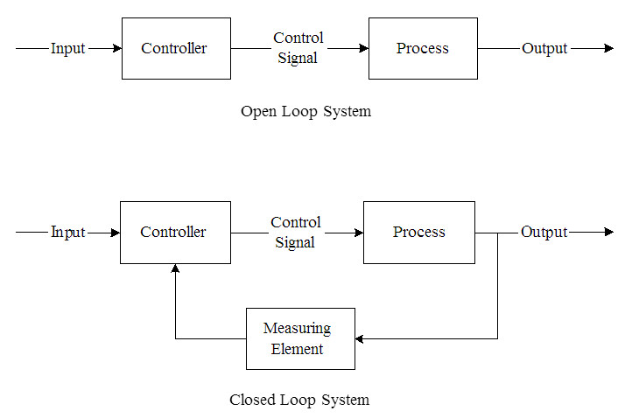

*Figure 11. Open loop and closed loop system*

We want to get accurate results from motor drive subsystem. Therefore we will connect encoders to DC motors to make this system closed. Compared to the open loop system, the closed loop system offered:

* Significantly improved velocity smoothness;
* Reduced overall current consumption;
* Higher torque at lower velocities.

**3.5.3.3 Differential Drive**

We choose differential drive system since it is easy to construct, and it is cheaper than the other drive systems since it requires only two dc motors and basic two wheels. This drive is based on two separately driven wheels placed on either side of the robot body. The direction of the robot can be changed by varying the relative rate of rotation of its wheels. Therefore, it does not require an additional steering motion. Some example motions with varying speed of wheels are shown in Fig. 12. Not that to balance the robot, we added two additional castor wheels.

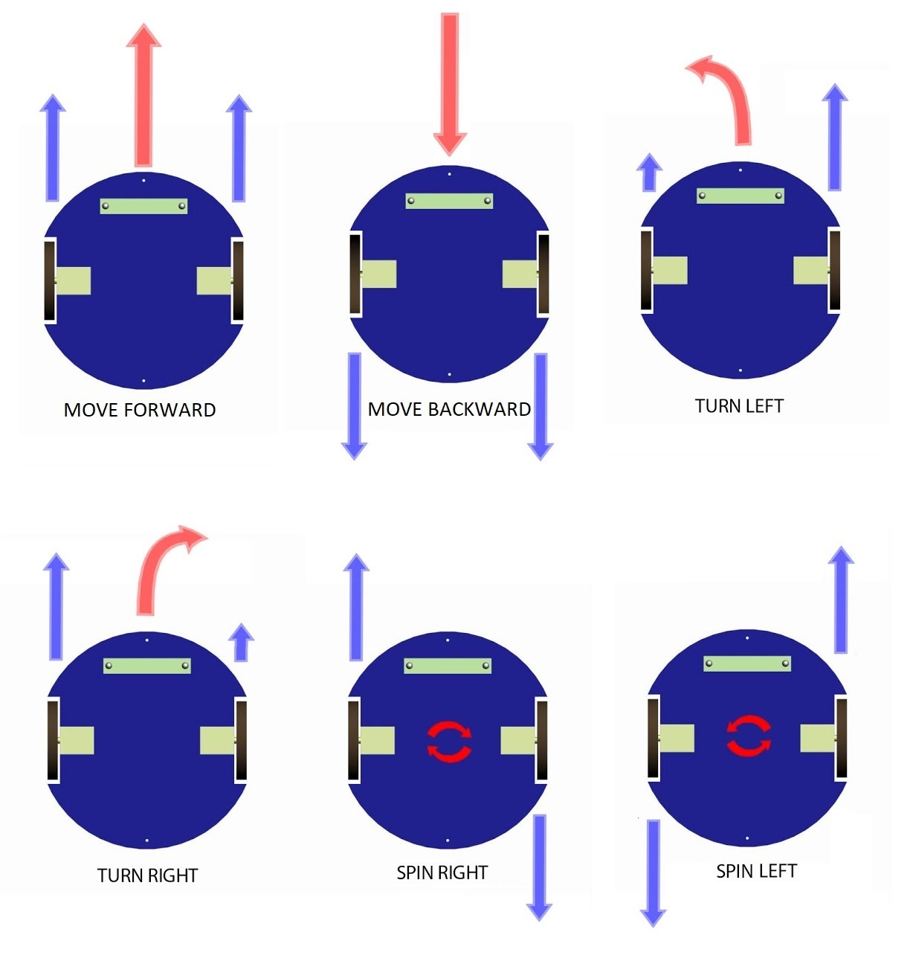

*Figure 12. Differential drive*

**3.5.3.4 DC Motor Drive with Arduino**

**i) Move Forward**

When user moves up the left analog of joystick, robot moves forward. For this operation, both DC motors should turn same speed and same rotation. This can be achieved with Arduino by setting the same PWM value to the both motor pins. Note that there are 3 different speeds that changing with left analog position.

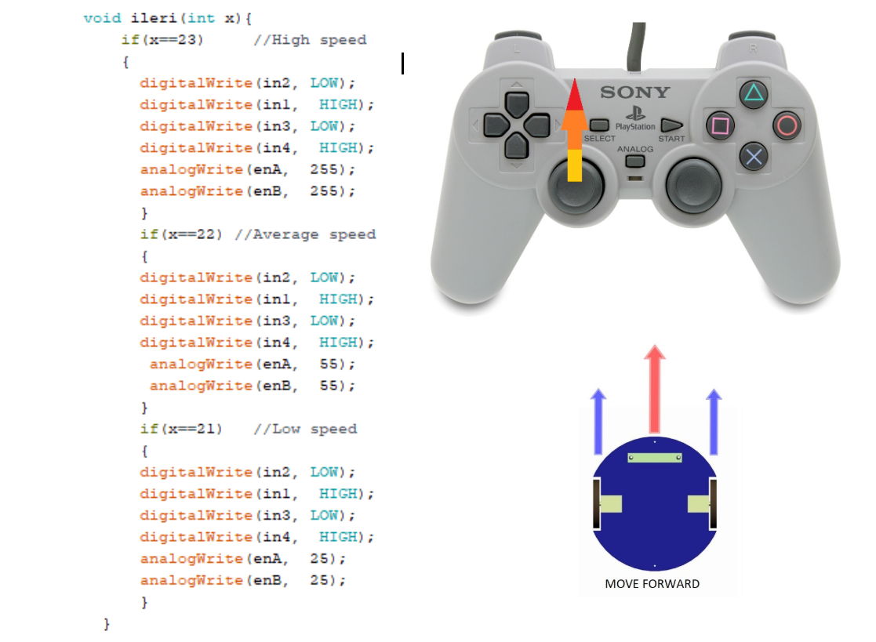

*Figure 13. Illustration of forward move with corresponding codes.*

**ii) Move Backward**

When user moves down the left analog of joystick, robot moves backward. For this operation, both DC motors should turn same speed and same rotation. This can be achieved with Arduino by setting the same PWM value to the both motor pins. Note that there are 3 different speeds that changing with left analog position.

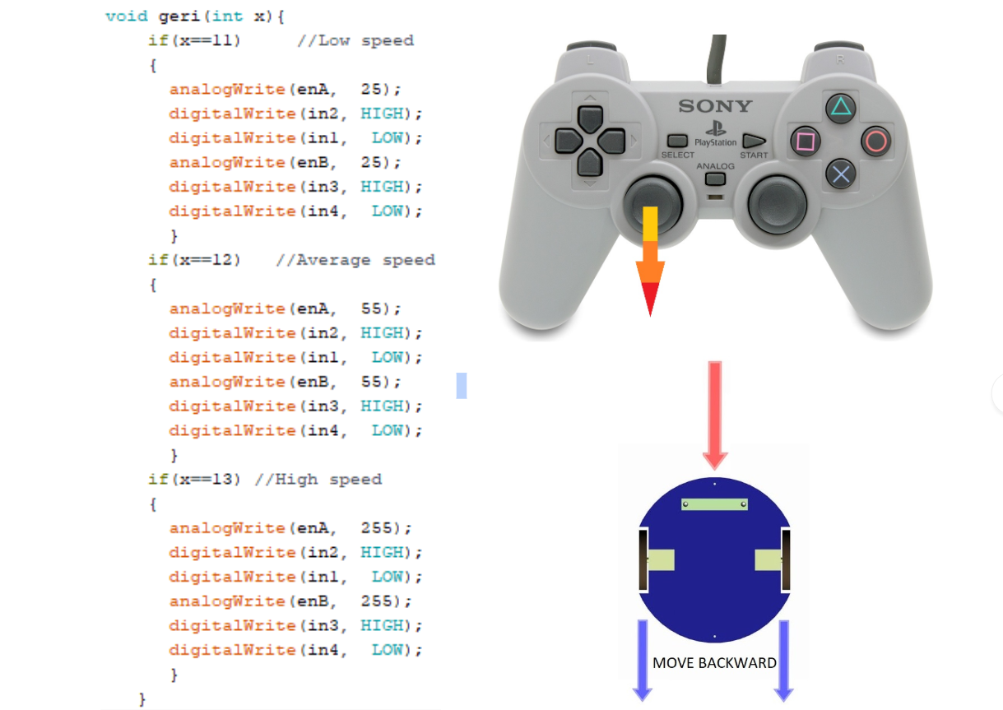

*Figure 14. Illustration of backward move with corresponding codes.*

**Iii) Spin Right**

When user moves right the right analog of joystick, robot spins right. For this operation, left DC motor should move forward and other DC motor should move backward at same speed. Note that there are 3 different speeds that changing with right analog position.  This can be achieved by changing the PWM values for the both motor pins.

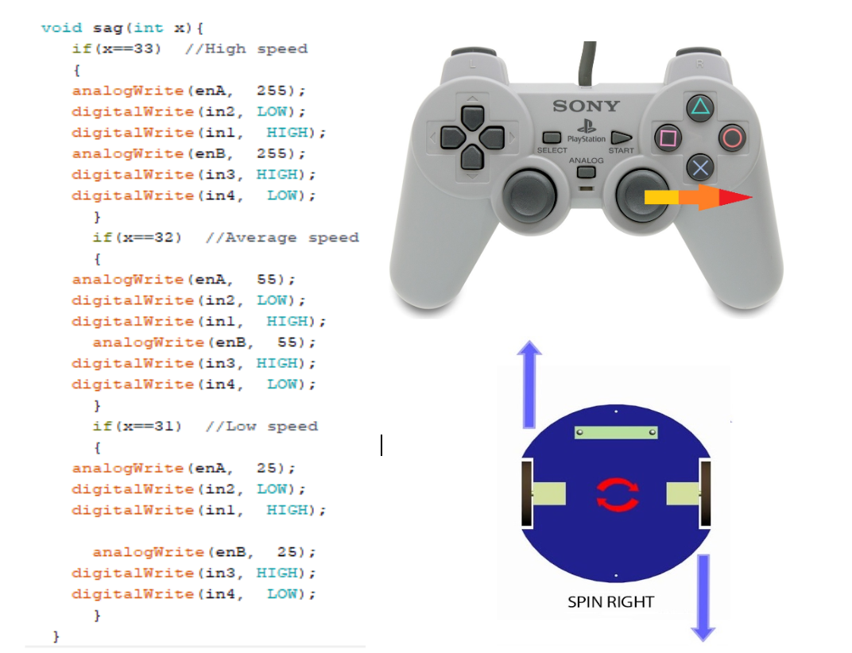

*Figure 15. Illustration of spin right move with corresponding codes.*

**iv. Spin Left**

When user moves left the right analog of joystick, robot spins left. For this operation, right DC motor should move forward, and other DC motor should move backward at same speed. Note that there are 3 different speeds that changing with right analog position.  This can be achieved by changing the PWM values for the both motor pins.

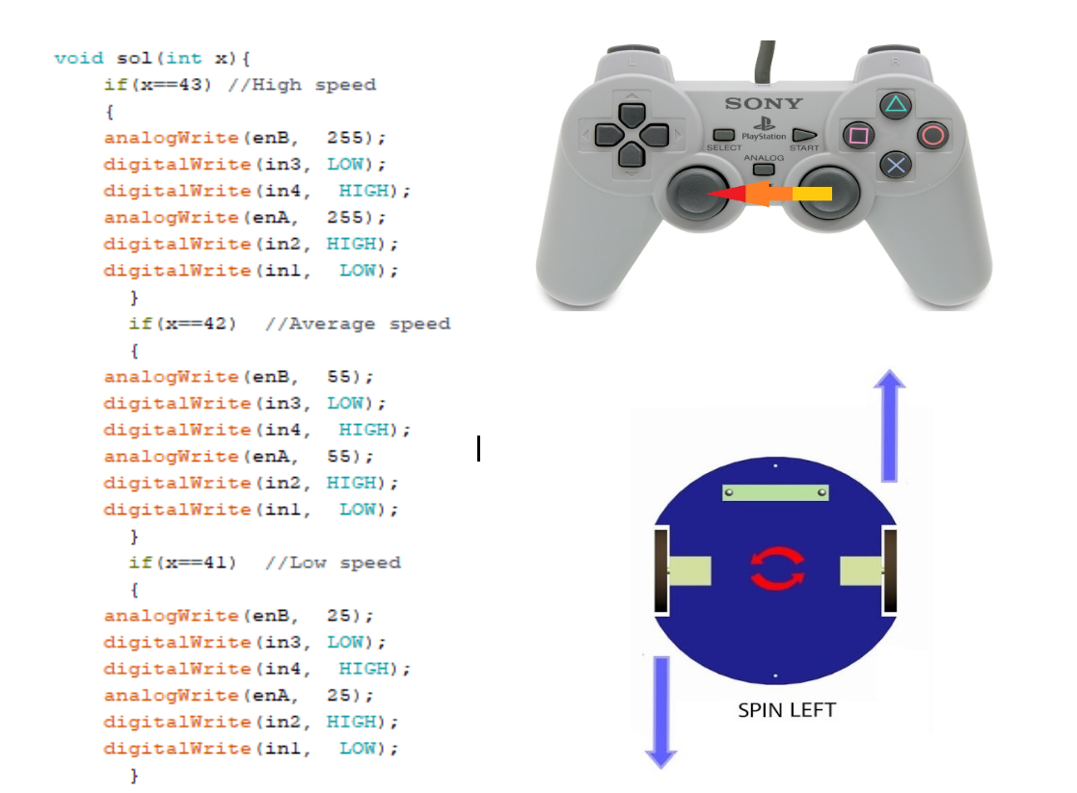

*Figure 16. Illustration of spin left move with corresponding codes.*

**3.5.4 Shooting sub-system**

Shooting system is an important part of the project for meeting all requirements. After the researches, we found three types of shooting systems which can be proper. In this part, properties and structures of these shooting systems will be defined.

**3.5.4.1. Spring Mechanism**

The first category contains systems based on mechanical stored energy in a spring. This system is a very simple mechanism. A spring is wound up, held, and released at certain moment of time. It is applied in various configurations. Varying from basic spring systems to crossbow-based mechanisms. Fig. 13 contains a simplified model of a standard spring mechanism.

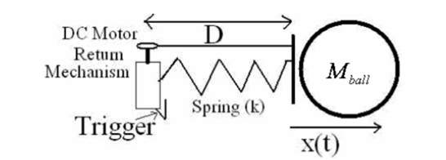

*Figure 17.  Schematic model of a spring-based shooting mechanism*

For this simple model the equation of motion holds.

https://lh3.googleusercontent.com/Xkrng6ThnkHZNbSSWrX8PsF6FaaK8GodAzAaleW7cFUZxinPB1GZRwTG2zUk8xdxpW2Fd5uiyfgTHuqtCuFlgtTFNpxhBM24Nkzd-mz0XdTxCx2TKFDwiLLJ-sarVqLMGH_Lq1S_

With Initial Values:

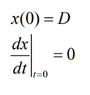

**Advantages:**

* The system is very powerful due to much energy can be stored in a spring
* The number of shots is almost unlimited, because it works on battery power

**Disadvantages:**

* It takes a lot of space, weights several kg and it takes about time to reload
* It is also very hard to control the shooting power
* There are 2 ways to obtain variable shooting power, by varying the spring’s displacement or by taking energy away with a variable damper. These are difficult solutions and is rather impossible to achieve variable shooting power “on demand” without any time lag.

**3.5.4.2 Solenoids**

The third idea for shooting mechanisms is through an inductive resistance in which when the electricity passes through a solenoid, a magnetic field will be created. When we increase the number of cycles or the amount of electricity, there will be a stronger magnetic field. The Magnet materials can be absorbed or repelled through a magnetic field and this is a phenomenon which is used in building solenoid.

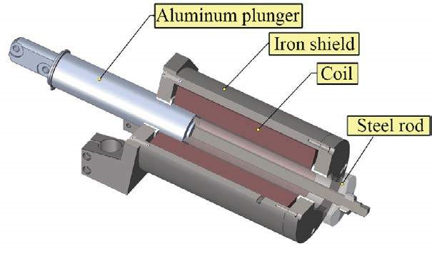

*Figure18: Schematic model of a solenoid-based shooting mechanism*

**Advantages**:

* + It is able to shoot very fast
  + It is rather small and lightweight
  + Only a transformer, a capacitor, some resistors and a switch is used so it is in theory very reliable
  + Shooting power can be varied by varying the time of the applied current

**Disadvantages**:

* + The use of a solenoid is that it operates at a high voltage and current, so it can be quite dangerous.
  + It uses a lot of power for a really short time
  + Due to internal resistance, heat is generated when activated

**3.5.5 Power Supply Subsystem**

For power supply subsystem, we use one 12v 2.8ah accumulator battery and two power-banks. Accumulator battery supply power for dc motors and video transmitter. Power-banks for Arduino and camera. That’s because motors and video transmitter work with 12V whereas camera and Arduino work with 5V DC. In addition, Arduino is used to supply power for command transmitter at the controller side and command receiver at the robot side. Therefore, nrf24l01 modules are directly connected to Arduino. The overall scheme is shown below.

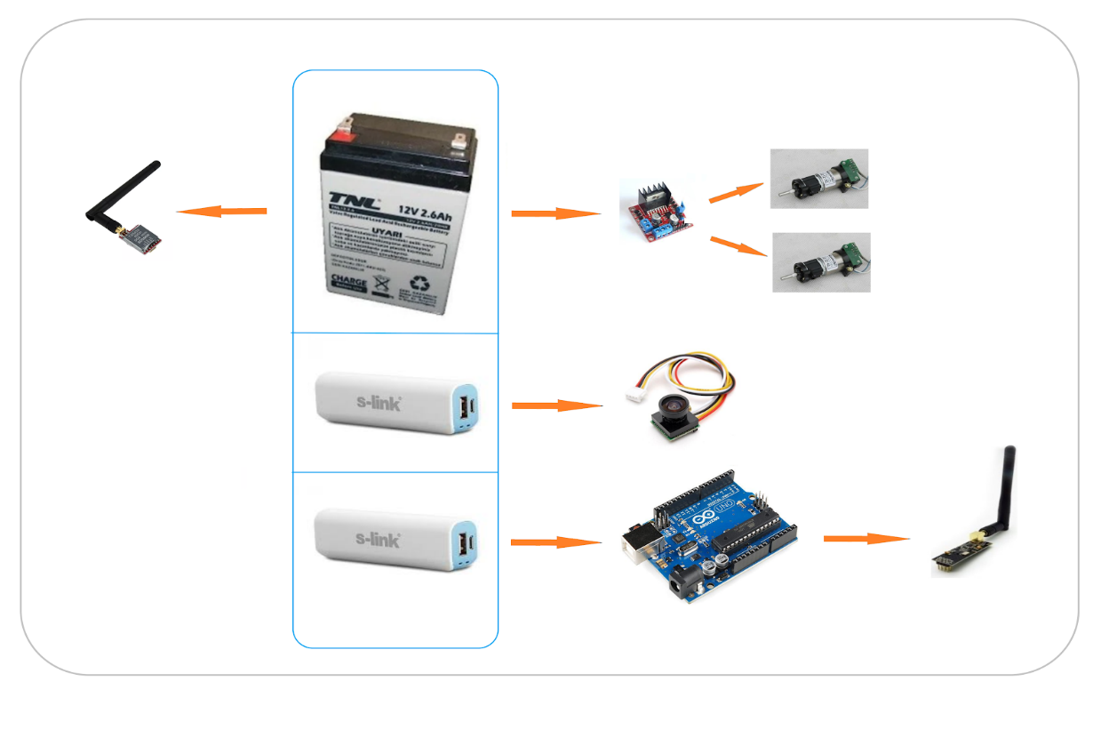

*Figure 19. Power Supply Subsystem Scheme*

**3.6 SUBSYSTEM LEVEL RISK ASSESSMENT, AND ALTERNATIVE SOLUTIONS (Plan-B)**

**3.6.1 Video Transmission Subsystem: Range**

We use 600mW transmitter at 5.8ghz. At that power, the output power of transmitter signal is 27dBm and the its 5.8ghz antenna has 2dBi power gain. This provides us enough range such as 1km at outdoor and the 50m+ at indoor to communicate. However, there is an extra option that we can use for improving range. We can use power amplifier for 5.8ghz which is amplifying 600mW output power to 2500mW so that the output transmitter power can be 34 dBm.The expected outdoor range is 5km and indoor range is 300m+ for us with that extra amplifier. This module works with 12V DC and it is easy to apply on our system. Its price is $20.

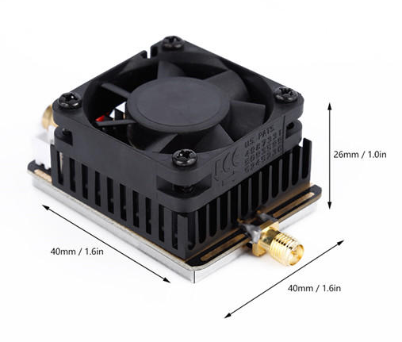

*Figure 20. 5.8Ghz Power Amplifier*

Besides improving transmitter power, we can also improve the sensitivity of the receiver part. In order to do that we can use cheap reflector for the receiver antenna. Its price is $3.

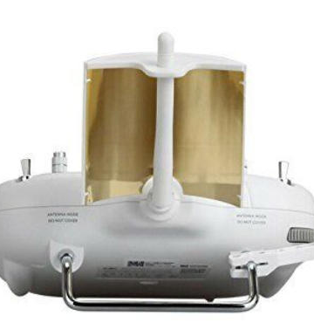

*Figure 21. Sample using of reflector for receiver antenna*

**3.6.2 Motor Drive System: Defense**

In our current motor drive subsystem, when robot turns left or turn right, also camera turns that direction with the robot. Therefore, user cannot see the ball or opponent robot if he wants to defense its goal by moving left and right. This can be solved by two different options:

**3.6.2.1 Using Movable Camera**

User can choose the direction of camera. By doing this, user can see the ball regardless of robot’s position. Movement of camera can be achieved by connecting it to a DC servo motor. And robot itself is moving with differential motor drive.

**3.6.2.2 Using Omni Wheels**

By using three omni wheels, robot would have capability to move every direction while the angle of view is stable or angle of view could be changed according to the players’ desire. It means that every movement and rotation would be achievable by building robot with omni wheels.

Omni-directional wheels are unique as they are able to roll freely in two directions. It can ether roll like a normal wheel or roll laterally using the wheels along its circumference. Omni-direction wheels allow a robot to convert from a non-holonomic to a holonomic robot. A non-holonomic robot that uses normal wheels has only 2 out of 3 controllable degrees-of-freedom which are,moving forward/backwards and rotation. Not being able to move sideways makes a robot slower and less efficient in reaching its given goal. The holonomic omni-directional wheels are able to overcome this problem, as it is a highly maneuverable. Unlike normal non-holonomic robot, the holonomic omni-directional robot can move in an arbitrary direction continuously without changing the direction of the wheels. It can move back and forth, slide ways and rotates at the same position.

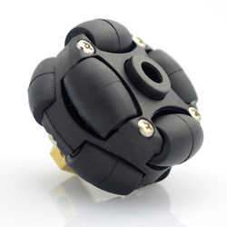

*Figure 22. Sample omni wheel*

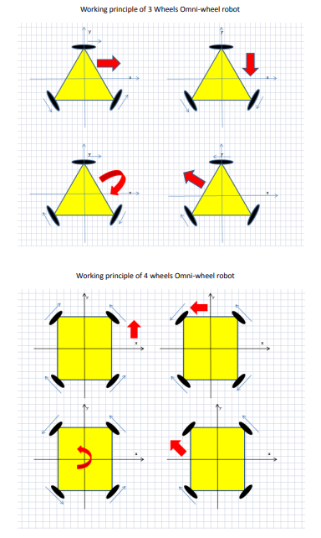

*Figure 23. Working principle of 3 omni wheel robot*

**3.7 ERROR SOURCES**

After doing researches and observing the environment, we concluded that these three subjects can be considered as error sources.

**i)     WALLS and PEOPLE**

Due to project standards, our robot has been designed as teleoperated. Wireless communication techniques are hired for transferring video and command data. So, walls of the demonstration places and people who exist in these places can pose obstacles for transmission of data. They may block data transmission, so lack of communication can be occurred.

**ii)     INTERFERENCE PROBLEM**

During the demonstration period, many robots are existed in the same place. There is a possibility of broadcasting at the same frequency and this may create a problem for us. Due to broadcasting of other groups, we can face interference problem in transmission of video data.

**ii)    FLOOR**

One of the main mechanisms of the robot is shooting mechanism. In order to obtain a proper shot, a smooth floor is required. However, both ‘Culture and Convention Center’ and ‘E building of the department of Electrical and Electronics Engineering’ have not completely smooth floors. That may affect direction of the shots and occur an error.

**3.8 TEST PROCEDURES**

Our test procedure starts with putting all the parts of one sub-system together. Before connecting the power supplies, we make sure that all the wire connections on integrated circuits are correct. In order to tune the sub-system to obtain its best operation performance, we change one variable at a time. In other words, if we want to measure the range that our transmitter antenna reaches, we keep all other parts the same while replacing the antenna by a different one. In video transfer sub-system, we used two 5.8 GHz receiver ROTG02s to compare the video quality. We connected different antennas to each receiver and tested them under the same conditions. For the outdoor usage tests, we put both receiver and transmitter parts in line of sight and measured the distance. For the video transmission we achieved 400m outdoor range at least.

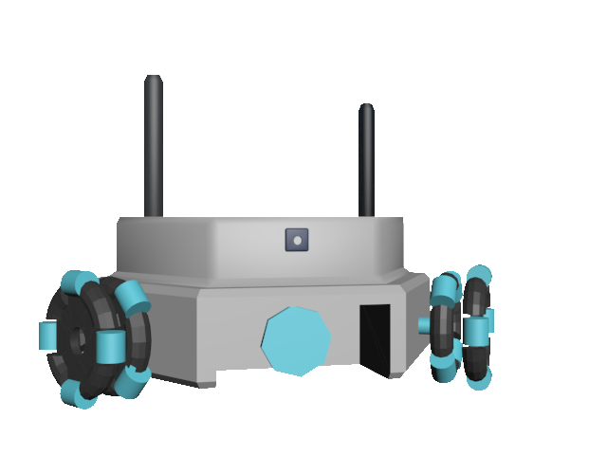**3.9 TECHNICAL DRAWING OF THE EXPECTED DESIGN**

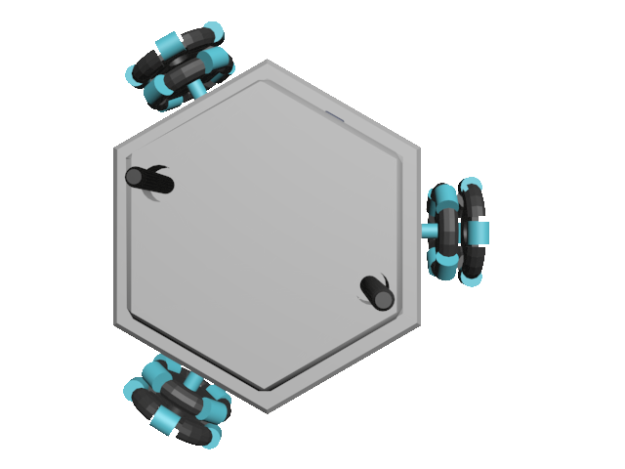*Figure 24. The front view of the robot*

*Figure 25. The top view of the robot*

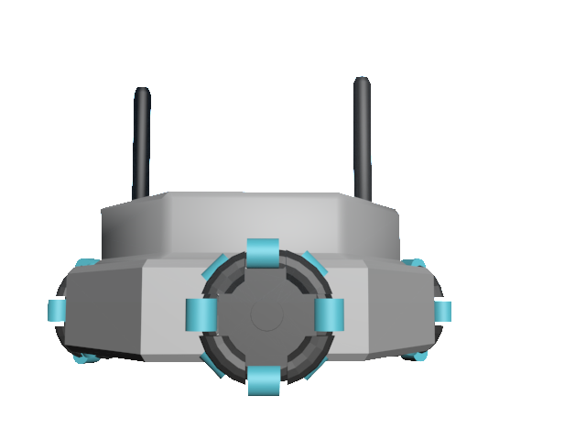

*Figure 26. The back view of the robot*

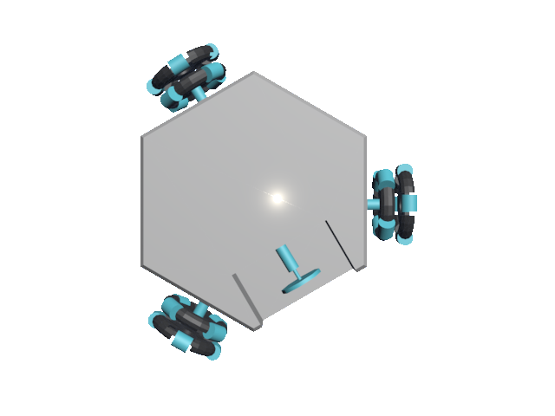

*Figure 27. The back view of the robot*

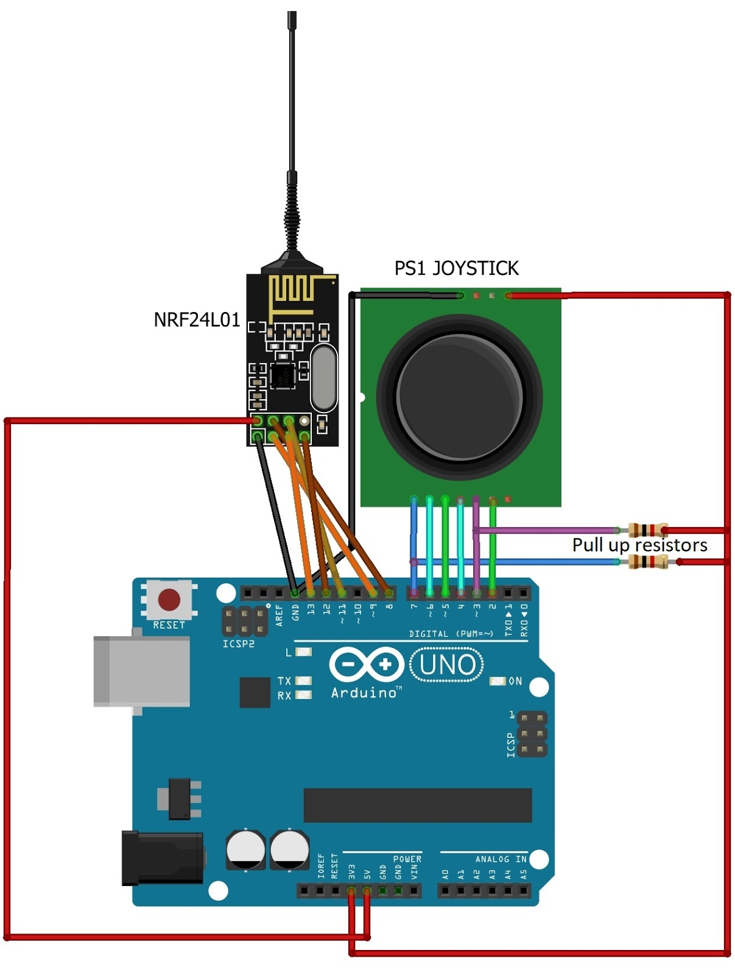

*Figure 28. Command Transmission system*

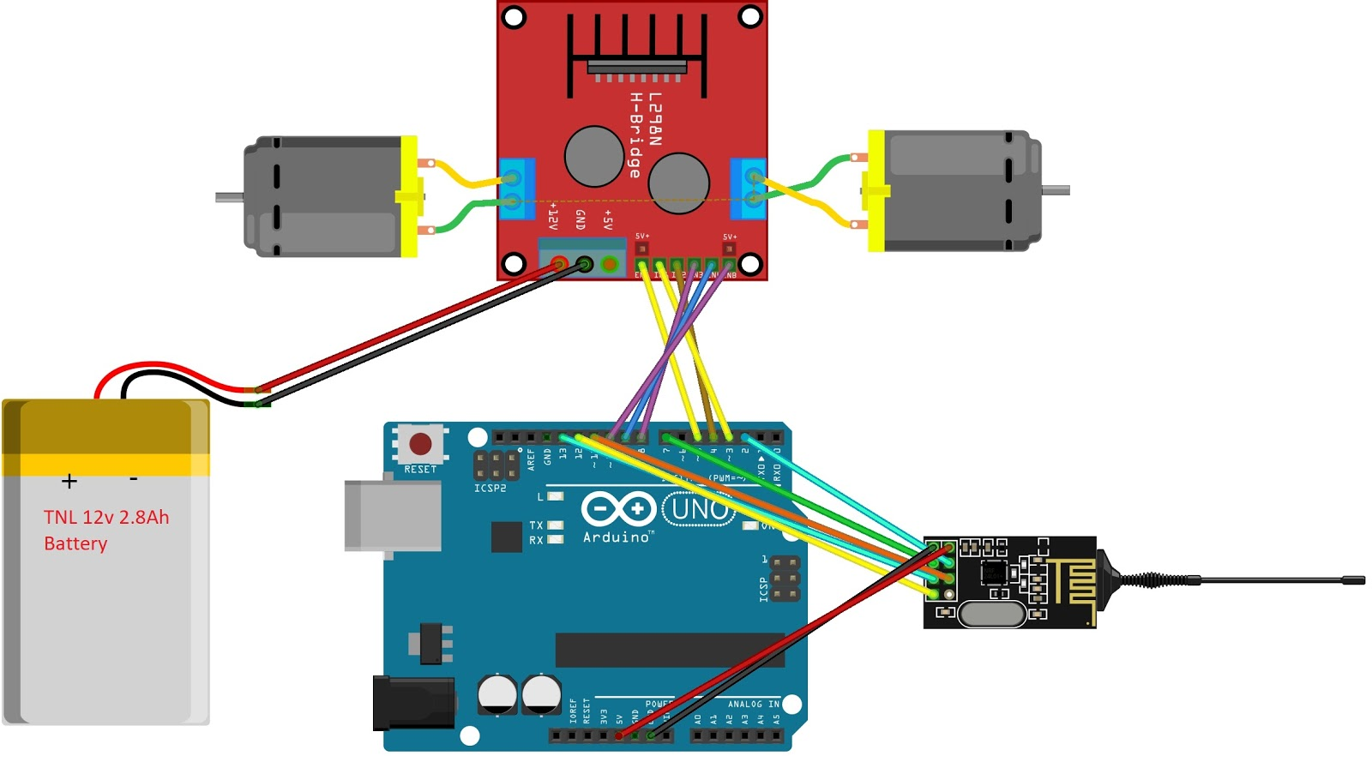

*Figure 29. Command Receiver and motor drive system*

**4. PLANS**

**4.1. PLANNED WORK AND RESPONSIBILITIES AMONG THE PROJECT MEMBERS**

As Troy Tech, we divide our total project work into some divisions between our company members. We distribute the work-load among the project team members according to their area of professions. First one is the software design team. Members of this subgroup are Caner Potur and Kağan Özaslan, their specialization area is computer. This subgroup is responsible for the programming of microcontroller units and the codes controlling the motor driver.  The second one is the communication and antenna subgroup. This team is responsible for mostly the hardware of the wireless communication part. The members of this group are Mert Kayış and Mustafa Ercan Okatan. Their area of specialization is microwaves and antennas. Hasan Özkara is from control area as the specialization in our department. He is responsible for the integration of different subsystems and the smooth control of the motor drive and shooting systems.

In our plans for the rest of this semester and the spring semester, the duty and responsibility of each group will remain the same, but as we did in this semester, if we face a critical test or design problem, we discuss it together by stating opinions of each individual in our company. We always attach importance to various professions in electrical and electronic engineering, however we also need different viewpoints to solve issues involved in robotics division sometimes. For example, when we are working on a tuning and development for usage of an antenna, our communication subgroup consults computer subgroup and take their advices related to the mentioned problem. In addition, all our team members explain what they form, add or change on their part of responsibility to other group members because we care about everyone should have knowledge related to different parts of this project.

**4.2. Gantt Chart**

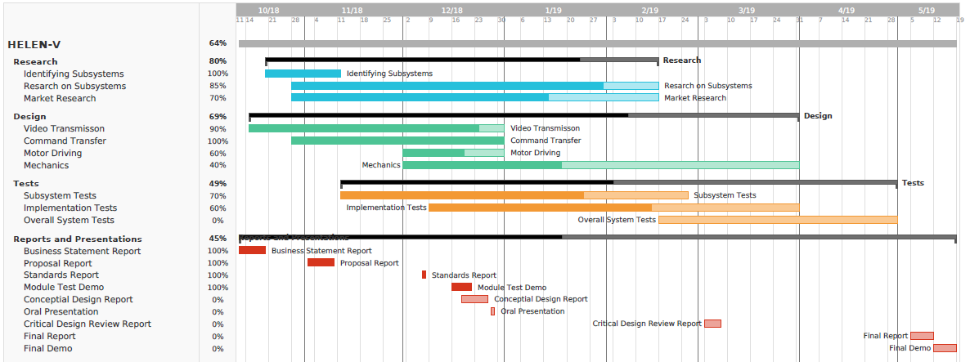

**4.3. Foreseeable Difficulties**

There might be some possible that we can encounter with in the future. For us, It is vital to determine these possible difficulties since knowing them give us opportunities to design modules preventing these foreseeable difficulties. These difficulties are listed below.

**i)** We might encounter disturbing noise on video display when the distance between the receiver and the transmitter become very large. Therefore, we cannot monitor the game field accurately.

Possible solution: We can use LC filters between the source and video camera module in order to avoid possible noises or we can use parallel capacitors.

**ii)** We might encounter some difficulties regarding to shooting mechanism. If we use solenoid system, a heating problem will reveal. Also, the magnetic field used in the shooting system can affect the other parts of the robot.

Possible solution: Although we can neglect this problem as the game duration is short and number of shoots will be limited, we can add heat sinks to our shooting system.

We can use a steel tube out of the solenoid for shielding.

**iii)** We can encounter interference problem in video transfer if there is another broadcast at the same frequency.

Possible solution: Our receiver module Rotg02 and the video transmitter have several channels whose operating frequencies are different. The Rotg02 module has 150 channels while TS5828 transmitter has 40 channels. If we encounter such a problem, we can change the channels.

iv) We might encounter a drive problem when we use differential drive since movement skill of the robot can be poor and we cannot defense properly.

Possible solution: We can use omni wheels and thus, we can improve the robot’s ability of movement.

**4.4. Test Plans**

In the remaining time of our project, we will continue doing the same testing procedure as we have been doing until now. The detailed explanation for the testing procedure is given in part 3.8 of this report. But in the spring semester, we will also test solutions in our backup plans in case of any trouble we might encounter. As we approach to the end of our project in the next semester, we will be able to test our all subsystems in an integrated form, in other words, all in one piece. In order to see the enhancement in each subsystem, single test result will not be enough, then we will compare each result with the previous one. By following this procedure, we will try to reach the best performance for our robot on the playfield. At the last stage, we will test our robot against a dummy robot which will be located on the opponent’s half of the playfield.

**4.5 Cost Analysis**

At the end of the first term we have built a prototype robot including wireless command transmission, video transmission and motor control on it. The only exception is shooting system on the robot. This prototype costs $95 as listed below. It means that we have enough budget ($105) to make a shooting system and also improve the overall system and subsystems. Also, if we will use omni wheels we expect to complete this project as it will cost below $160, otherwise by using differential motor drive, we expect to complete below $120.

|  |  |  |  |
| --- | --- | --- | --- |
| **Product** | **Pieces** | **Unit Price($)** | **Total Price($)** |
| nrf24l01+ | 2 | 1.78 | 3.56 |
| TS5828s | 1 | 7.70 | 7.70 |
| Camera | 1 | 6.27 | 6.27 |
| Video Receiver | 1 | 21.99 | 21.99 |
| Arduino uno | 2 | 3.21 | 6.42 |
| Joystick | 1 | 2.84 | 2.84 |
| 15dBi antenna | 2 | 2.24 | 4.48 |
| 12V Battery | 1 | 9.55 | 9.55 |
| Power-bank | 2 | 4.75 | 9.50 |
| DC motor | 2 | 8 | 16 |
| L298n | 1 | 1.43 | 1.43 |
| Connection equipment and body | 1 | 5 | 5 |
| **TOTAL** | **17 pcs** |  | **94.74** |

**Links for Products**

nrf24l01 = <https://bit.ly/2Sl34Xk>

TS5828s = <https://bit.ly/2QOGyJS>

Camera  = <https://bit.ly/2QNpZhs>

Video receiver = <https://bit.ly/2ENhqwI>

Arduino Uno = <https://bit.ly/2Sl35eb>

Joystick = <https://bit.ly/2Sl3eyf>

Antenna = <https://bit.ly/2EPMls2>

Battery = <https://bit.ly/2Cxq9kr>

Powerbank = <https://bit.ly/2BCGgez>

DC Motor = Gözeler Elektronik, Konya Sokak, Ulus, Ankara

Motor driver = <https://bit.ly/2EOb1Rf>

**4.6 DELIVERABLES**

We will provide our customers with some documents and tools besides the robot itself. A user manual, a certificate of warranty for maintenance service, battery charger, a ball, walls of the playfield. Documents will show under how circumstances the best performance can be received from this product. We will also explain some basics of controlling the robot in the user manual document. The number of expected deliverable items may increase if we find something necessary in the spring semester.

**5. CONCLUSION**

We described the general procedure and the project purpose which is “Designing and constructing one of the two teleoperated robots trying to shoot and score in opponent’s goal” in the proposal report. In this conceptual design report, we presented the solutions for the specified problems. Beside of the solution, we mentioned alternative solutions in case of operational troubles. In order to define the solutions, we explained determination of the content of subsystems and selection of the electronic devices. After the solution part, we gave information about plans, management and design strategies.

As mentioned above, the robot is mainly composed of teleoperation, robot movement, catching and shooting system for a ball. During the design period, the company has designed a minor system which contains external antennas to make teleoperation precise. Moreover, for getting a proper movement, we create a software to supply our motors a speed control option. Catching and shooting system has not been implemented yet. In the process of designing the project, we paid much attention to subsystems. We tested our subsystems lots of times, so we could observe problems and come over them at the beginning. We made progress step by step to ensure that our robot work perfectly.

Engineering design project can be considered as an introduction to our following engineering life. It contributes opportunities of gaining experience from every field of the department. Troy Tech will deliver a perfectly working final product together with the deliverables, within a short timeframe and economic budget. The aim was finding an intelligent and engineering solution. This effort and ambition were the basis of completing the almost one half of the project duration successfully.

**6. DISCLAIMER**  
  
Troy Tech's design complies with all the standards of the selected project, namely the “Devices trying to score in each other’s goals “.

Hasan ÖZKARA 2031888 __________________________

Kağan ÖZASLAN 2031854 __________________________  
  
Caner POTUR 2031250 __________________________

Mustafa Ercan OKATAN 2031193 __________________________  
  
Mert KAYIŞ 2030997 __________________________

**7.REFERENCES**

Hamby, C. (2013, November 26). Top Benefits And Top Disadvantages To Using A 5.8 GHz Frequency? Retrieved from<https://www.avalan.com/blog/bid/354696/Top-Benefits-And-Top-Disadvantages-To-Using-A-5-8-GHz-Frequency>

Perlman, A. (2016, August 20). Everything You Need to Know About FPV Flying. Retrieved from https://uavcoach.com/everything-need-know-fpv-flying/

User’s Basic Guide to Radio Control Systems. (n.d.). Retrieved from http://www.rcmodelswiz.co.uk/rc-guides/electric-rc-models-guide/users-basic-guide-to-radio-control-systems/

Wheel Control Theory. (n.d.). Retrieved from http://www.robotplatform.com/knowledge/Classification_of_Robots/wheel_control_theory.html

**APPENDICES**

**APPENDIX A - *Command Receiver and Motor Drive Subsystems***

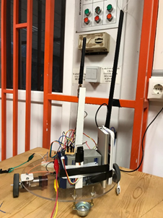

*Figure 30.  Command Receiver and Motor Drive Subsystems*